# Spring Framework – Exercise 4 Implementation Report

## Maven Project Creation

A new Maven project named **LibraryManagement** was created using IDE support (Eclipse/IntelliJ) or manually using the Maven CLI.

**Directory Structure:**

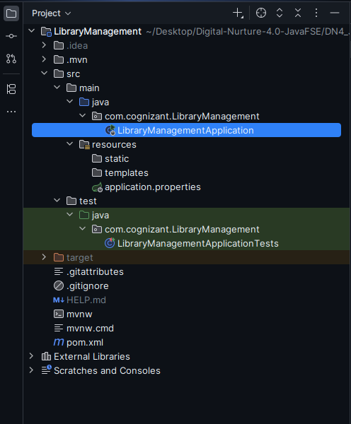

## Added Spring Dependencies in pom.xml

The following Spring modules were added:

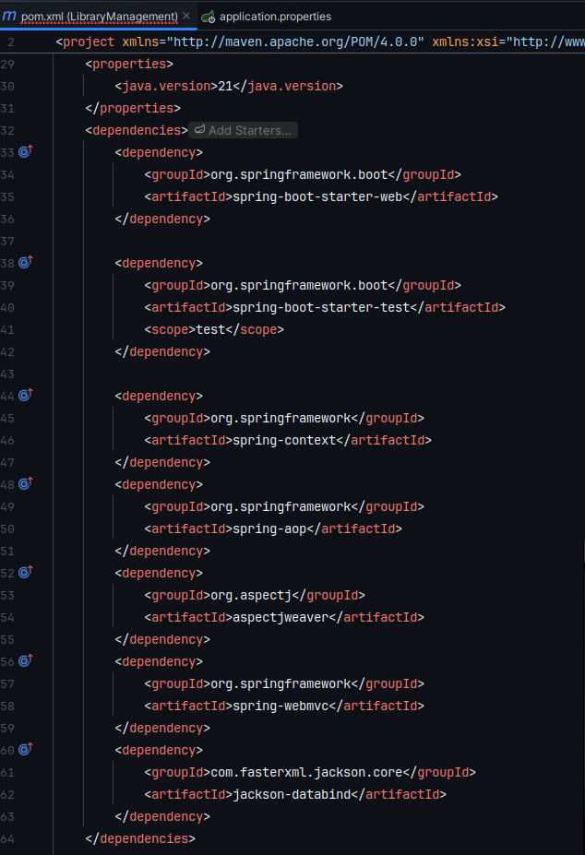

## Configured Maven Compiler Plugin

Configured Maven to compile code using Java 1.8:

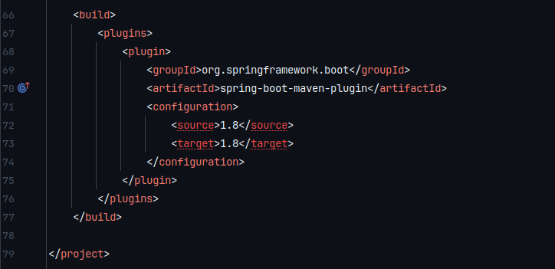

## Build Verification

Executed: mvn clean install

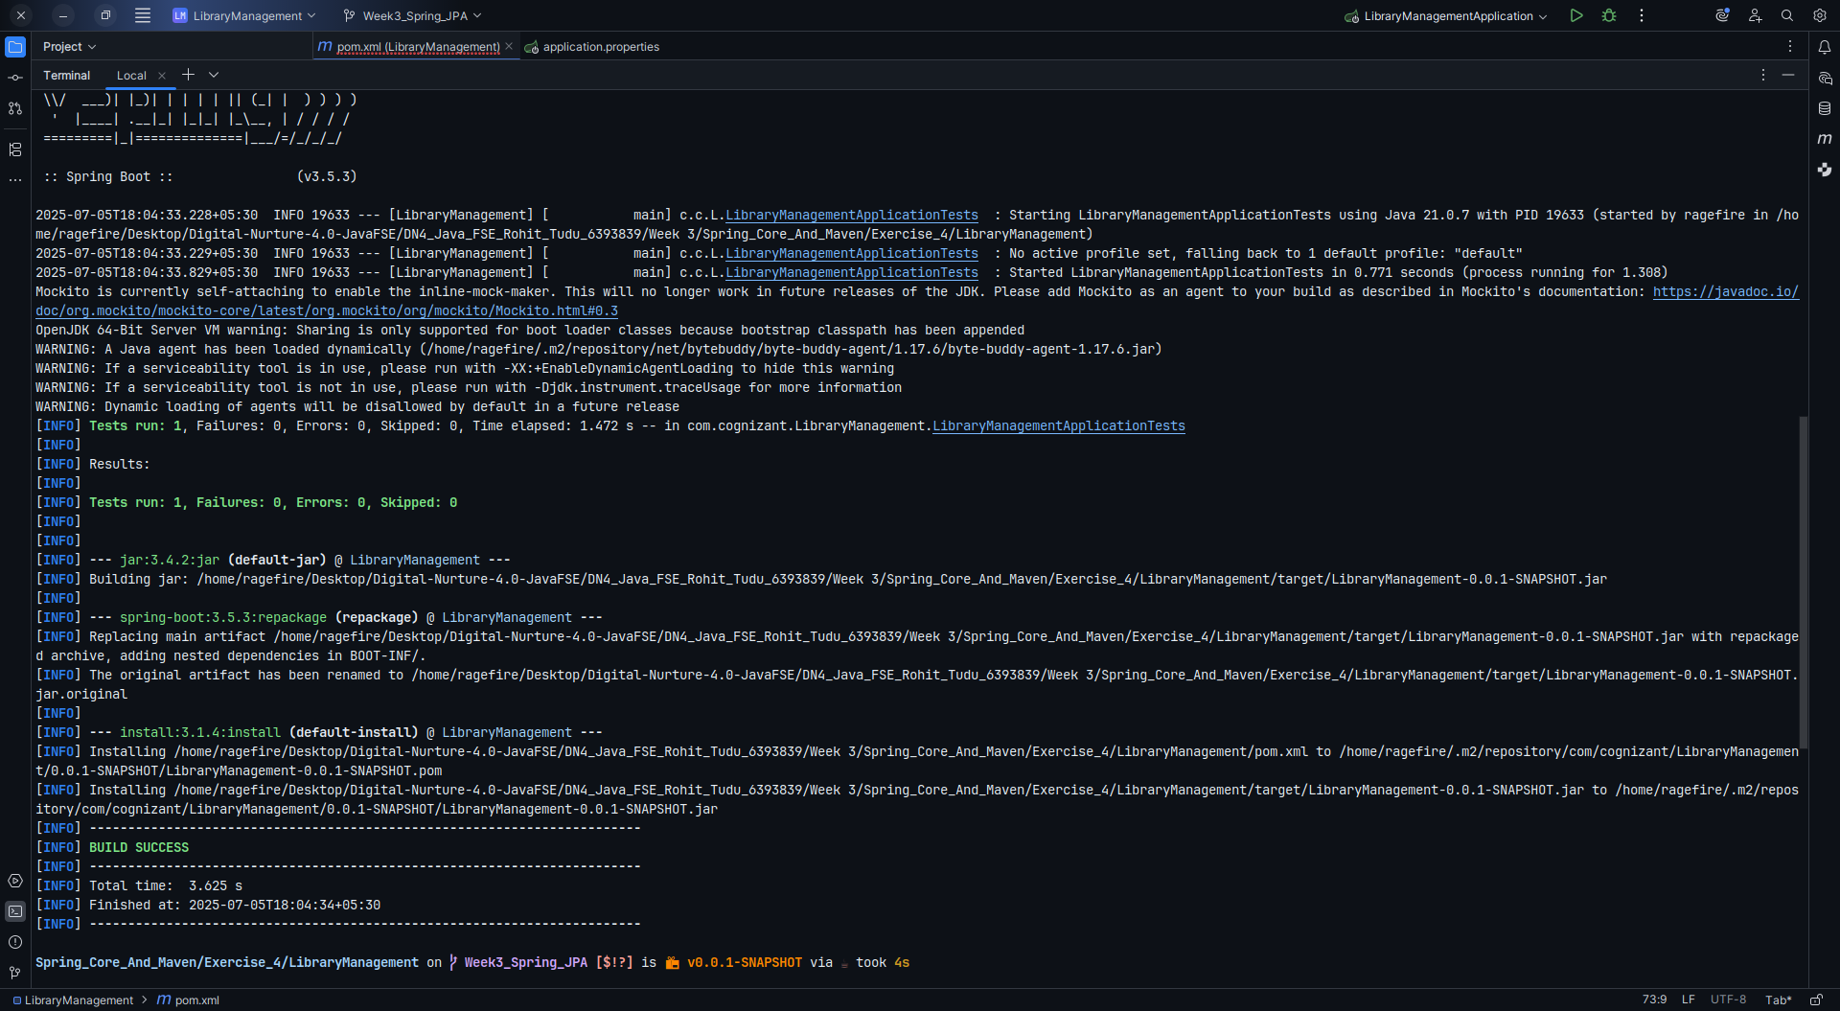

## Outcome

A functional Maven project named LibraryManagement is now set up

Required Spring modules (context, aop, webmvc) added

Maven compiler plugin ensures Java 1.8 compatibility

Project is ready for Spring-based development and further configuration (DI, Controllers, Beans, etc.)